Student’s name | …………………………………………………….…… | Grade | 1
Subject | Computer | Week No. | 7
Lesson Title | Introduction to Multimedia | Unit
Worksheet No. ( 7 ) (Answer)

Question A: write the correct name of each part

Speakers | Headphones | Monitor


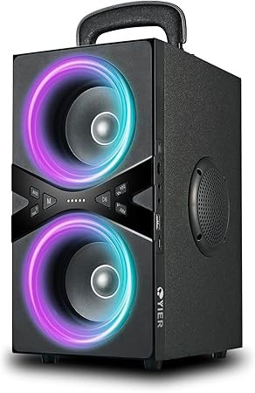
Speakers
Monitor
Headphones
Good Luck

